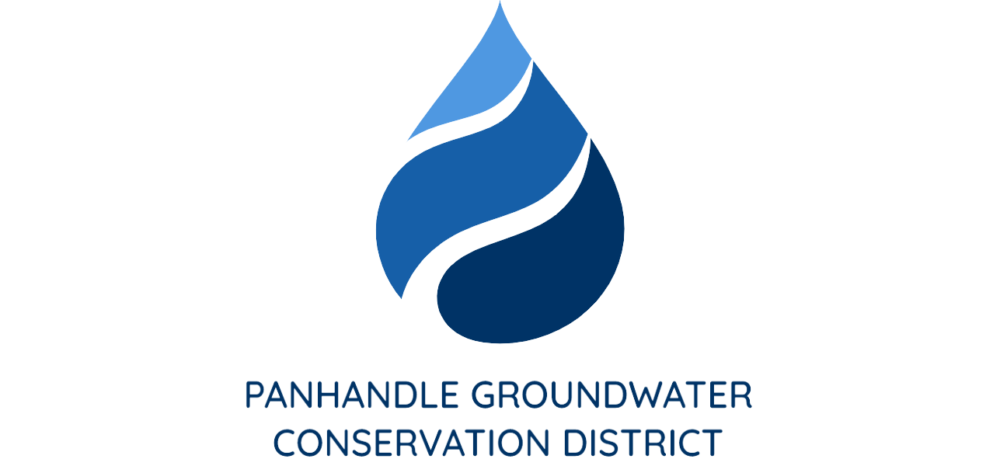

PRESS RELEASE
Contact: Britney Britten, General Manager
Panhandle Groundwater Conservation District
(806) 883-2501
britney@pgcd.us

FOR IMMEDIATE RELEASE

Good For Texas Tour stop in Amarillo, Texas with Texas Comptroller, Glenn Hegar

WHITE DEER, TX. (September 14, 2022) – Texas Comptroller, Glenn Hegar, is kicking off his Good for Texas Tour in Amarillo, TX.

Comptroller Hegar will be highlighting the importance of maintaining and continuing to invest in Texas’ water management and infrastructure. This stop on the tour will focus on Panhandle Groundwater Conservation District’s (PGCD) Precipitation Enhancement Program.

PGCD General Manager, Britney Britten said, “This is an incredible opportunity for our District and our region. We are very excited to see water as the topic of the Comptroller’s tour this year.”

Hegar will be touring Trandwind Airport and discussing operations with PGCD’s meteorologist and pilots. The media conference will be held on Tuesday, September 20 at 11:00 a.m.

Tradwind Airport is located at 4105 Tradewind St. Amarillo, TX 79118.

